

Interactive Kitchen

This movie will contain only 1 scene and the scene will only be one frame long!

The first thing we need to do is set the size of our movie, we want this movie to be 750 px wide and 565 px high. The background colour should be bright yellow (FFFF00).

Modify > Movie
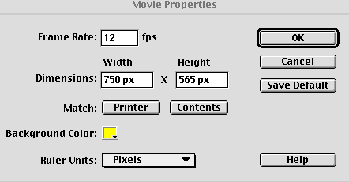

To make our life easy we can also use a grid to help us draw.

View > Grid > Edit Grid

Scene 1
Layer 1

The first layer will contain the background.

Select layer 1 and re-name it background”

Set the line thickness to 2 points, black and no fill.
Draw the cupboards and skirting board using the rectangle tool.
Draw the tiles, work top and cupboard doors using the rectangle tool with the corner radius set to about 5. (I pulled the lines out slightly at the side of the cupboard and doors to make them look a bit better).
Then draw the door handles with the circle tool.

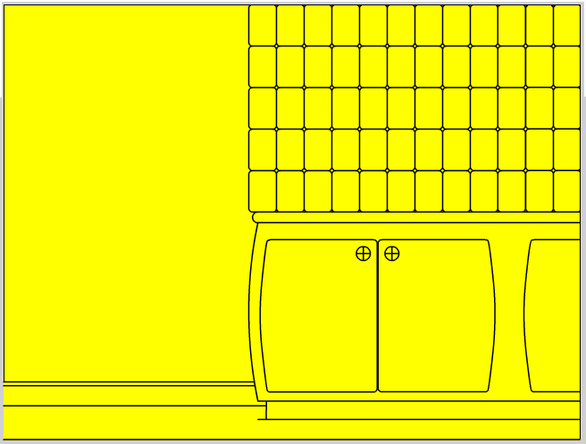

This is the background layer nearly finished, we just need to add some colour using the paint bucket tool.

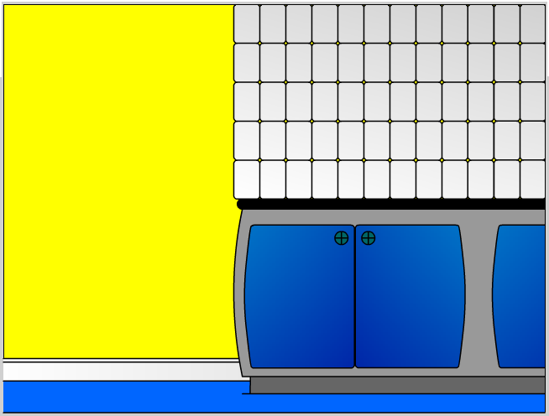

And that is our first layer finished. Click the padlock icon next to the layer name to stop yourself from changing the background by accident.

Layer 2

The second layer in the animation will contain the fridge.

Insert a new layer above the “background” layer.

Select layer 2 and re-name it “fridge”

Using the rectangle tool, set the line thickness to 2 points, black, no fill and with the corner radius set to about 5, draw the fridge.

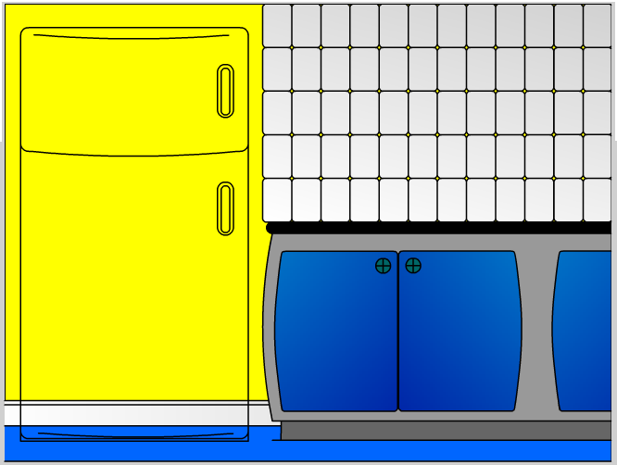

You can hide the background layer while you draw if this makes it easer for you, just click the eye next to the layer name in the timeline.

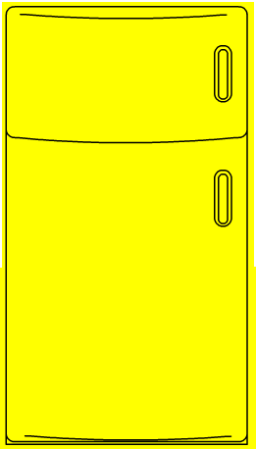 Add some colour and…… 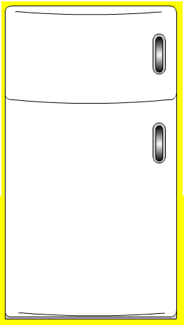

The last thing we need to do is record the position of our fridge, so that when we make the magnetic letters and numbers, people will be able to move them around the fridge, but not off it.
To be able to do this we need 2 sets of numbers, the top left and the bottom right positions of the fridge. To find these out make sure your info panel is open:

Windows > Panels > Info

Then position your mouse roughly where the red crosses are on the picture below and Wright down the X and Y positions from the info panel. Keep these we will need them later.
Mine were:
TL=X:31,Y:40 BR=X:290, Y:525

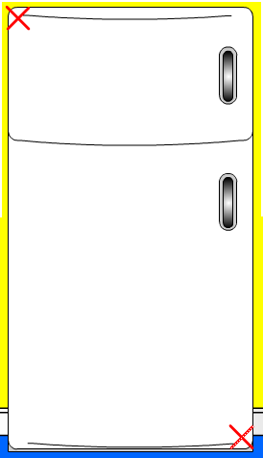

Layer 3

The next layer in the scene will contain the interactive/movable letters and numbers.

Insert a new layer above the “fridge” layer.

Select layer 3 and re-name it “letter & numbers”

First we need to make some buttons – we need one for each movable letter or number!

But instead of making 47 or more different buttons we will create only one and use it lots of times!

Insert > New Symbol

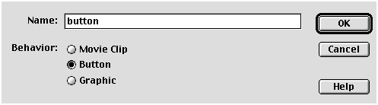

Click OK and you should have a blank window.

This in not going to be an ordinary button, this will be an invisible button. To create an invisible button we only draw in the Hit state on the timeline.

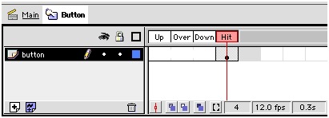

So in the hit state only draw a small circle as shown below and the return to scene 1.

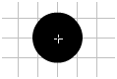

Now we have our button in the library we can start making all our letters and numbers.

Still in our “letters & numbers” layer, select the text tool and type a letter “a” on the fridge. I used Arial Rounded MT Bold for the font as it looks a bit like fridge magnet letters, and a font size of 27 points.

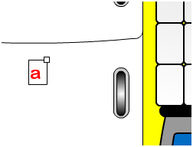

With the letter selected go to:

Insert > Convert to symbol

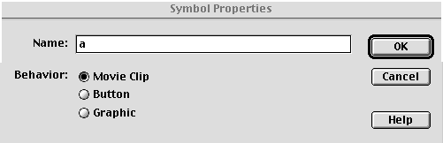

Choose Movie Clip and name it “a”

As soon as we convert the letter into a symbol it will appear in our library.

Now using the library double click on the “a” movie clip we just created. We are now editing the movie clip.

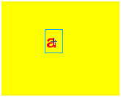
All the background will disappear while we are editing, but this is just so we can see what we are doing.

The time line for the “a” movie clip only has one layer, we need to add a second layer above this to put in a copy of the button we created earlier.

Insert a layer above layer 1 and name it button. Then drag a instance of the “button” symbol from your library and place it over the letter “a”.

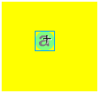

The button will appear translucent blue to show it is there but invisible.

Now we need to add some Actions to the button so that people will be able to move the letter around the screen.

Select the button, and open the actions panel:

Windows > Actions

We need to tell flash that when someone presses the mouse button on top of the button, they can move it around the screen, and when they let go of the mouse button it should stay were they left it.

On the left of the Actions panel are some ‘books’.
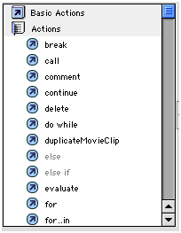

Click on the ‘Actions’ book and it will open, choose “startDrag”. Then choose “stopDrag”

Your actions should now look like this:

on (release) {
startDrag ();
}
on (release) {
stopDrag ();
}

We now need to edit these basic actions to create the effect we are after.

If you click your mouse on the actions , were it says “on (release) {“ the first time, some extra options will appear underneath.
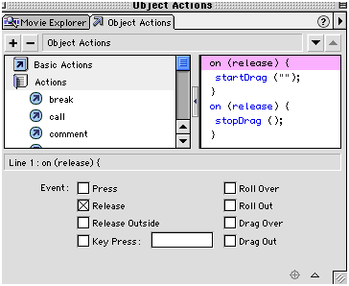

Change “Release” to “Press”

Click were it says “startDrag ();”
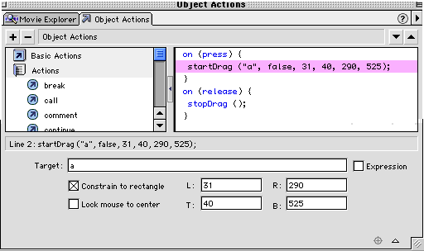
Change the Target to “a”, and put it the X and Y values we got from the fridge (Left, Top and Right, Bottom).
Putting in the top left and bottom right X and Y values restricts the movement of the letter to a box the same size and in the same position as the picture of the fridge we drew.

Now we need to stop editing the letter “a” and go back to the main scene.

The letter “a” we made should still be there, if not simply drag it from your library onto the fridge.

With the letter “a” still selected open you instance panel:

Window > Panel > Instance

And name this instance of the letter “a”.

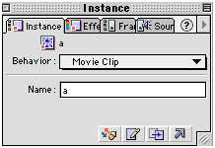

At this point you should save and test your movie, make sure you can move the letter “a” around the fridge but not off the fridge. You might need to change your X and Y values a few times to get them just right.

The Other Letters & Numbers

To create all the other letters and numbers faster we can simply duplicate our “a” movie clip (using the library) and make some small changes.

So for the letter “b” all we need to do is duplicate “a” and rename it “b”.
Then double click on it in the library so we can edit it, change the letter “a” for the letter “b” and change its colour.

We also need to change the button actions slightly, the only thing we need to change in the actions is the line:

startDrag (“a”, false, 31, 40, 290, 525);

To:
startDrag (“b”, false, 31, 40, 290, 525);

And when we put the letter “b” into the main scene call its instance “b” instead of “a”.
Select the letter “b”:

Window > Panel > Instance

And name this instance of the letter “b”.

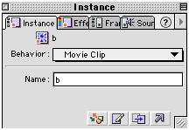

You need to repeat this until you have all the numbers and letters required.

Once all the letters and numbers are finished and the instances renamed within the main scene, the fridge part of our kitchen is finished and we can lock all the layers to prevent accidentally moving anything.

Save, export and test!

Back To Main Scene

So we have all the background done and the fridge is working fine. The next thin to do is make the toaster.

Insert a new layer above the “fridge” layer.

Select layer 4 and re-name it “toaster”

Draw a toaster on the work top, I used the rectangle tool with the corner radius set to 5, pulled the top line a bit to give it more of a curve, then added a bit of shading.

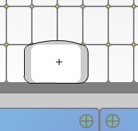

Select the toaster and convert in into a movie clip named “toaster”.

Insert > Convert to symbol

This will give the toaster symbol its own time line so we can make the toast pop out when ever we want.

Double click on the toaster in the main scene, this allows us to edit in place, so we can still see the background.

Select frame 60 in the toaster layer and insert a frame, this makes the toaster animation 60 frames long.

Insert a new layer above the toaster layer.

Insert a new layer above the “toaster” layer

Select layer 2 and re-name it “actions & buttons”

Drag an instance of our invisible button from your library and place it on top of the toaster, but in the “actions & buttons layer”. Using the Scale tool stretch it to cover the toaster.

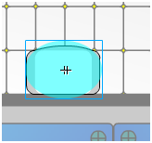

Select the button, and open the actions panel:

Windows > Actions

Open the basic actions book and double click play.

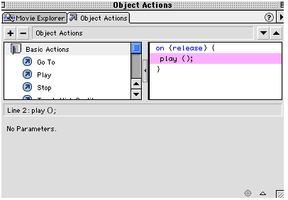

That is all the actions for the button, but we also need to add some frame actions.
With the actions panel still open select the first frame in the “actions & buttons” layer. Open the basic actions book and double click stop.

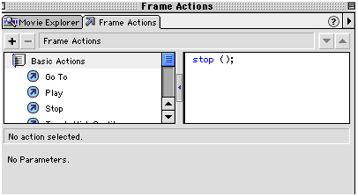

That is all the actions for this scene; you can close the actions panel.

Now for the toast.

Insert a new layer above the “action & buttons” layer

Select layer 3 and re-name it “toast 1”

Draw a piece of toast.

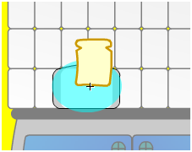

When you are happy with how your toast looks, we need to create a guide for the toast to fly along.

Insert a guide layer above the “toast 1” layer

Using the pencil tool set to smooth, draw a guide line as shown bellow:

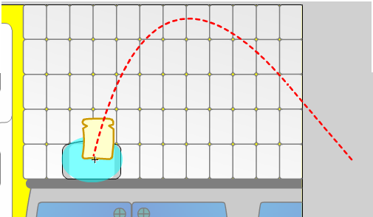

Select frame 60 in the guide layer and insert a frame to extend the time line.

Then select the toast in the toast 1 layer and create a motion tween:

Insert > Create Motion Tween

Then insert keyframes at frames 11, 50 and 60. Then move the toast in the relevant frames as shown:

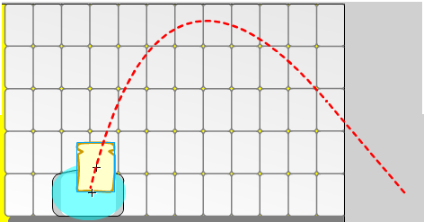
Frame 1
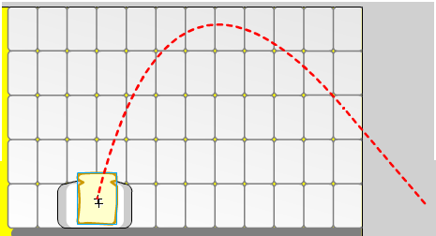
Frame 11

Frame 50

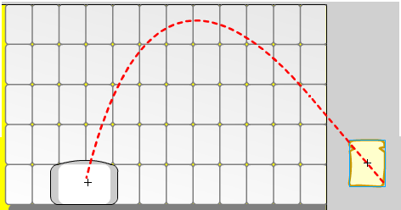
Frame 60

Your time line for the toaster should now look like this:
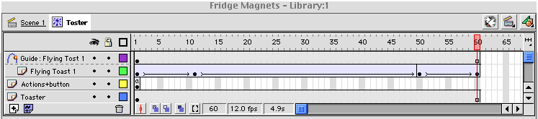

The toaster is nearly finished we just need to change the layer order slightly because the toast is on top of the toaster at the moment.

Simply drag the “toaster” and the “actions & buttons” layers to the top.

Your time line should now look like this.
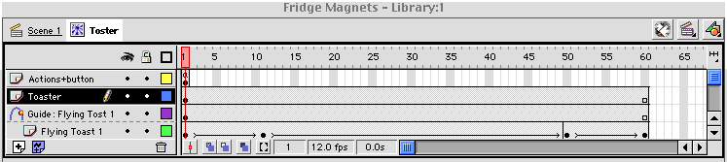

The toaster is now finished, save, export and test!

Back To Main Scene

The next thin to do is make the kettle.

Insert a new layer above the “toaster” layer.

Select layer 5 and re-name it “kettle”

Draw a kettle on the worktop.
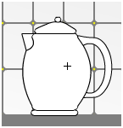

Then added a bit of shading.
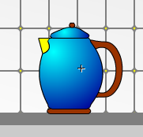

Select the kettle and convert in into a movie clip named “kettle”.

Insert > Convert to symbol

This will give the kettle symbol its own time line so we can make it boil whenever we want.

Double click on the kettle in the main scene, this allows us to edit in place, so we can still see the background.

Select frame 15 in the toaster layer and insert a frame, this makes the toaster animation 15 frames long.

Insert a new layer above the “kettle” layer

Select layer 2 and re-name it “actions & buttons”

Drag an instance of our invisible button from your library and place it on top of the kettle, but in the “actions & buttons layer”. Using the Scale tool stretch it to cover the kettle.

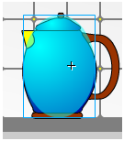

Select the button, and open the actions panel:

Windows > Actions

Open the basic actions book and double click play.

That is all the actions for the button, but we also need to add some frame actions.
With the actions panel still open select the first frame in the “actions & buttons” layer. Open the basic actions book and double click stop.

That is all the actions for this scene; you can close the actions panel.

Now for the steam.

Insert a new layer above the “action & buttons” layer

Select layer 3 and re-name it “steam”

Draw three clouds of steam.
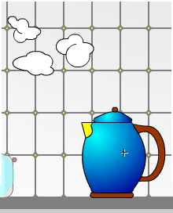

select your steam clouds and create a motion tween.

Insert > Create Motion Tween

Now select frame 10 in the steam layer and insert a keyframe.

Go back to frame 1 and select your steam clouds and move and shrink them as shown below:
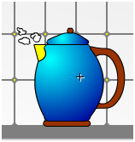

Now select frame 15 in the steam layer, insert a keyframe and move the clouds again as below:
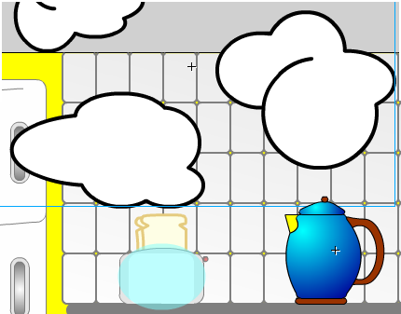

Then change the alpha value of the clouds to 0 using the effects panel.

Our kitchen is now finished! Export the movie and try it out!

